**LAB 9:**  **JUNCTION FIELD EFFECT TRANSISTORS**

Name:

**Objective:**

To study transfer and output characteristics of an n-channel Junction field effect Transistor (JFET) in Common-source configuration.

**Learning Outcomes:**

Able to analyze the characteristics of an n-channel Junction field effect Transistor (JFET) in Common-source configuration.

**Instrument/Component:**

Variable Voltage Supply

Digital Multimeter

Resistors: 1 kΩ

N Channel JFET (NTE 312/any)

**THEORY: Construction & Characteristics of JFET**

JFET(Junction Field Effect Transistor) is a three terminal device(drain, source, gate) similar to BJT. The difference between them is that the JFET is a voltage controlled device, whereas BJT is a current controlled device. Figure 9.1 shows the NTE 312 N Channel JFET symbol and real device.



**Figure 9.1**

**Drain Characteristics:**

For JFET, the relationship between an output parameter, ID, and an input parameter, VGS, is more complex. In the saturation region, there exists a square-law transfer relationship.

**Transconductance Characteristics:**

In the transfer characteristics of a two port network, the input parameter is changed and its effect on the output parameter is observed. Similarly JFET can be treated as a two-port nonlinear network. The transfer characteristics wherein the input parameter is the voltage across gate and source, and the output parameter is the drain current are called the transconductance characteristics. The transfer gain is nothing but conductance, hence the name.

**Task 1: Measuring ID versus VDS (Output Characteristics)**

1. Build the circuit as in Figure 9.2 properly.

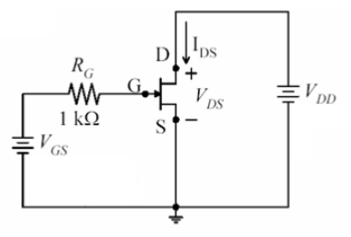

**Figure 9.2**

1. Set a particular value of voltage for VGS (i.e. 1V). Vary the voltage across drain (VDD) from 0 to 8V with steps of 0.5 V and measure the corresponding drain current (IDS).
2. Repeat the procedure for different values of VGS. (0V, -0.5V, -1V, -1.5V, -2V).
3. Plot the graph IDS versus VDD.



**Task 2: Measuring ID versus VGS (Transconductance Characteristics)**

1. Using the same circuit, set a particular value of voltage for VDS, i.e. 5V. Start with a gate voltage VGS of 0 V, and measure the corresponding drain current (IDs). Then decrease VGS in steps of 0.25 V until VGS is -3V. At each step record the drain current.
2. Plot the graph IDS versus VGS.
3. Calculate the transconductance parameter from the graph assuming your VGSQ value is -1 V.



**Discussion:**

Use all of the data obtained to answer the following questions:

1. Discuss the output and transconductance curves obtained in lab? Are they what you expected?

Answer:

1. Are the output characteristics spaced evenly? Should they be?

Answer:

1. What are the applications of JFET?

Answer: